For teachers / educators
Lead-in
- Depending on your learners, use the text below to create an information share gap-fill, a running dictation or a reading comprehension activity:
Insects have been around far longer than Homo sapiens yet their importance is often overlooked because they are so miniscule and easy to forget about. However, their significance is huge and they are vital for supporting life, on land as well as below water.
Insects have diversified through 400 million years of the Earth’s changeable climate, but insects are responding to recent climate changes in temperature and precipitation in ways that should be of concern, for example, many species are facing extinction. Investigations indicate that climate change impacts on insects have the potential to be considerable - perhaps we should consider them the ‘canary in the coal mine’. What could this mean for Homo sapiens?
But why are insects so important? Insects are the most diverse lineage of multicellular organisms on the planet. Their jobs in maintaining ecosystems are extensive and involve: soil engineers, pollinators, pest controllers, decomposers and providers. It is often said that, without insects, our species would not be able to survive.

- Discuss with your learners how insects might be relevant in the following Sustainable Development Goals (SDGs) that were adopted by all United Nations Member States in 2015. These goals are to be actioned by 2030 so let’s get learning, understanding and acting!
“How do you think insects play a role in these Global Goals for Sustainable development (SDG)?”
- SDG 6: Ensure availability and sustainable management of water and sanitation for all.
- SDG 14: Conserve and sustainably use the oceans, seas and marine resources for sustainable development.
- SDG 15: Protect, restore and promote sustainable use of terrestrial ecosystems, sustainably manage forests, combat desertification, halt and reverse land degradation and halt biodiversity loss

- Watch some clips of ‘David Attenborough life in the undergrowth BBC Earth’ on YouTube to get your learners interested and excited about insects.

The Earth Warriors this month will learn about different insects near where they live.
Page 2 is for making notes and page 3, when complete, is to be uploaded to www.stemgingereducation.com or emailed to info@stemgingereducation.com

For learners
The Earth Warriors this month will learn about different insects.
In science animals are classified in different ways:
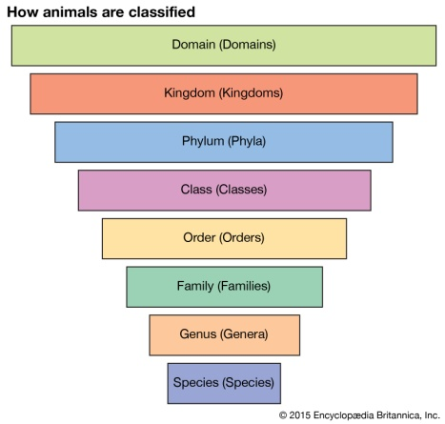
There are five orders of insects:
Ordonata | Lepidoptera | Hymenoptera | Coleoptera | Orthoptera
Dragonflies  Damselflies | Butterflies  Moths | Bees, wasps  Ants | Beetles | Grasshoppers  Crickets

Find an insect where you live (in your house, in your garden or a nearby park), you can also look online for insects that are common in your country.
Draw a picture of the insect, identify which order it belongs to and learn what its ‘job’ is (soil engineer, pollinator, pest controller, decomposer or provider). What other information can you learn about this insect? Surprise us with some interesting facts!
The insect I have chosen to learn about is: ______________________________________
It is from the order: _____________________________________________________
It lives in: ____________________________________________________________
Draw your insect here

More information: ___________________________________________
_______________________________________________________________________________________________________________________________________________________________________________________________________________________________________________________________________________________________________________________________________________
Final project to be emailed to: info@stemgingereducation.com

Group name: __________________________
Insect: ___________________________
Order: ___________________________

____________________________________________________________________________________________________________________________________________________________________________________________________________________________________________________________________________________________________________________________________________________________________________________________________________

